Day-22

1.Simple Signal Handler:

Write a C++ program that handles the SIGINT signal (Ctrl+C) gracefully by printing a custom message before exiting.

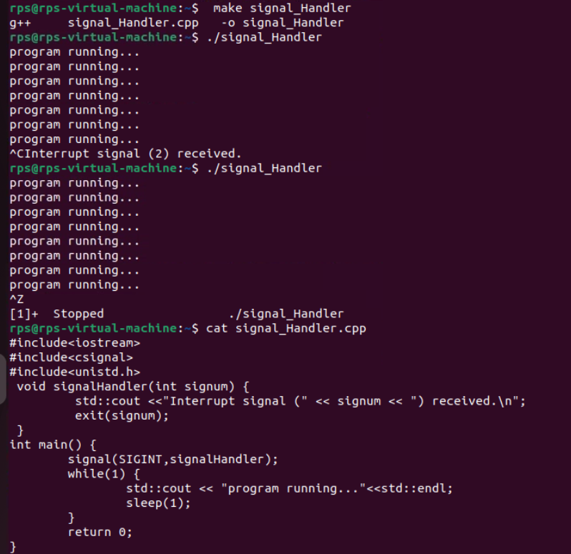

2. Multiple Signal Handling:

Create a program that handles both SIGINT and SIGTERM signals, printing a different message for each.

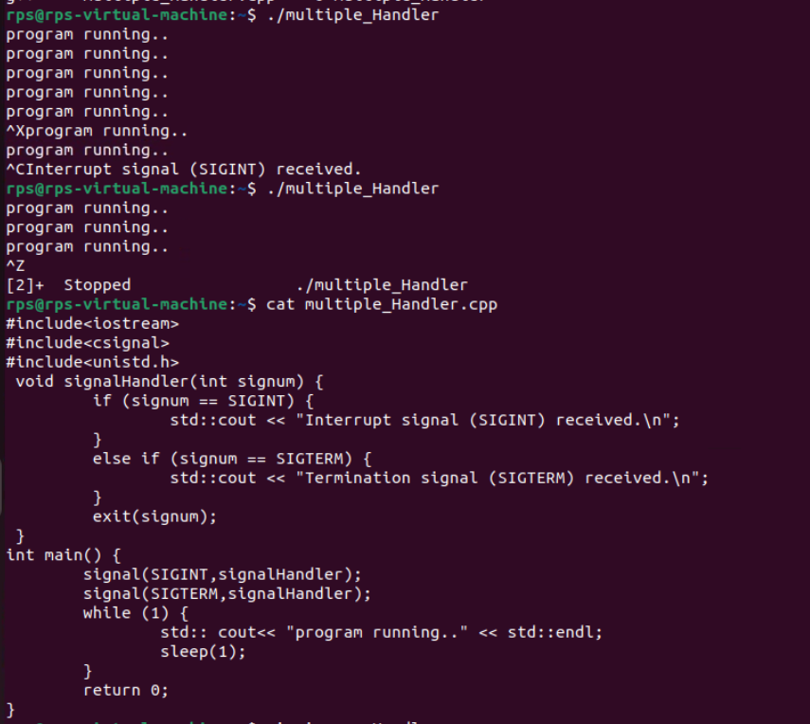

3. Ignoring Signals:

Develop a program that ignores the SIGTERM signal and continues execution even after it's sent.

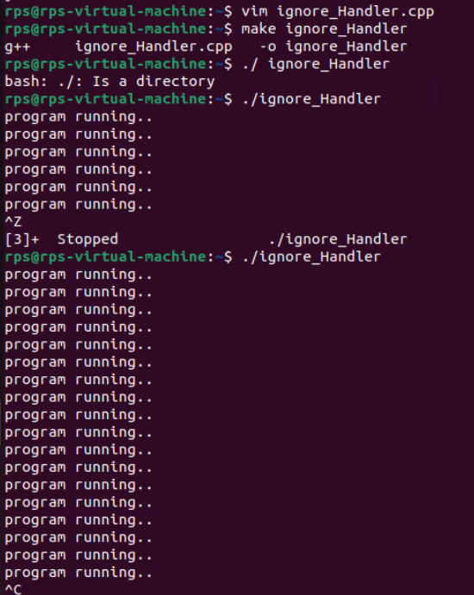

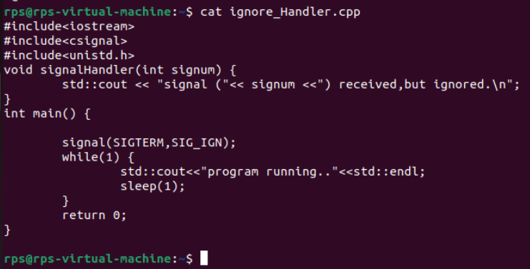

**Sig_raise:**

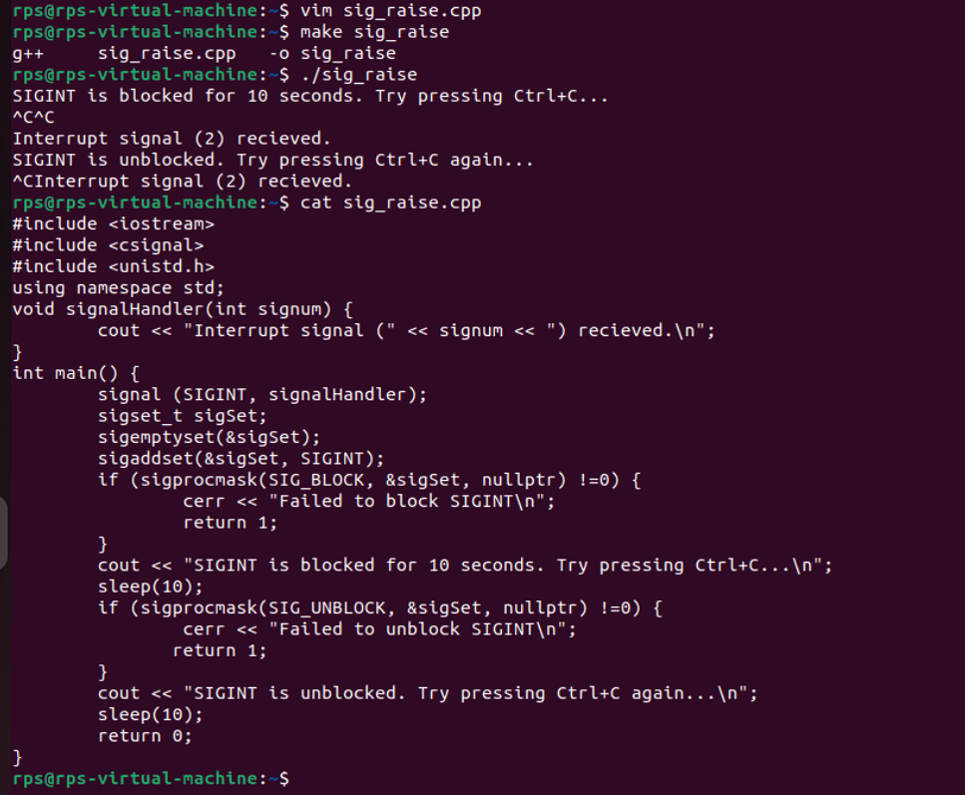

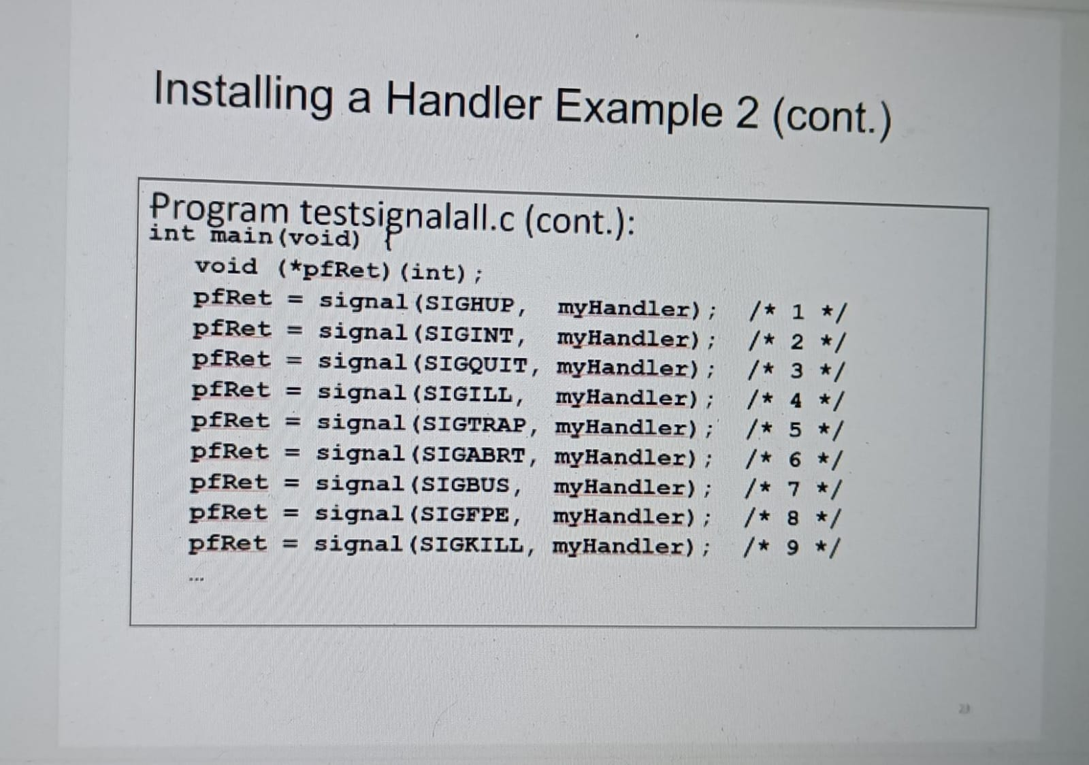

write a code where you handle signals from 1-9 as shown

and try to mask few and handle others and test

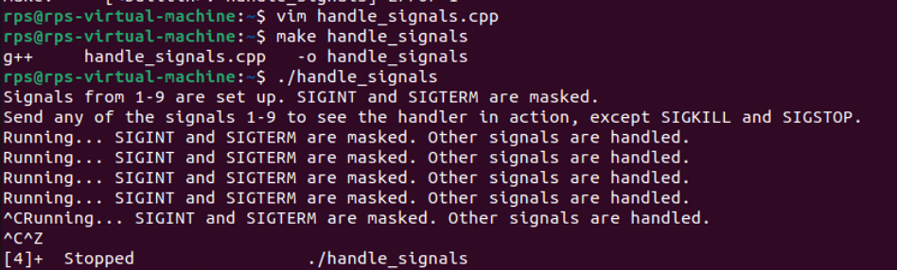

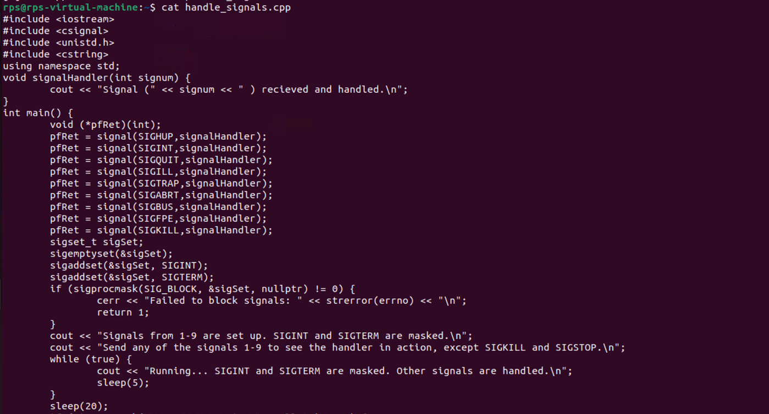

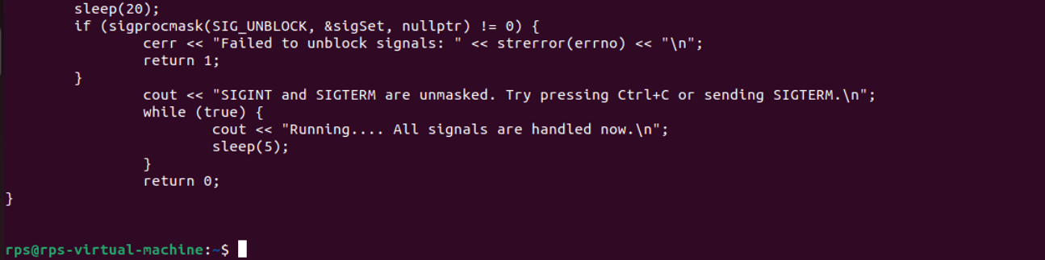

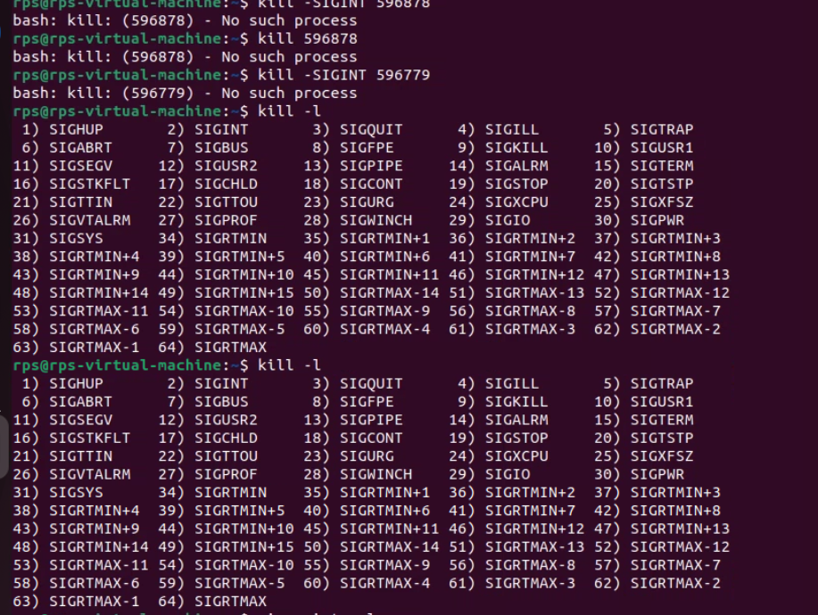

Problem Statement 2: Signal Masking and Unmasking for Graceful Shutdown

Problem: Develop a C++ application that gracefully handles termination signals (e.g., SIGTERM, SIGINT) by masking specific signals during critical operations and unmasking them afterwards. Implement a clean shutdown procedure that ensures all resources are released before the process exits.

Key Challenges:

Determining the appropriate signals to mask during critical operations.

Ensuring timely unmasking of signals to avoid process hangs.

Implementing a robust shutdown mechanism that handles unexpected interruptions.

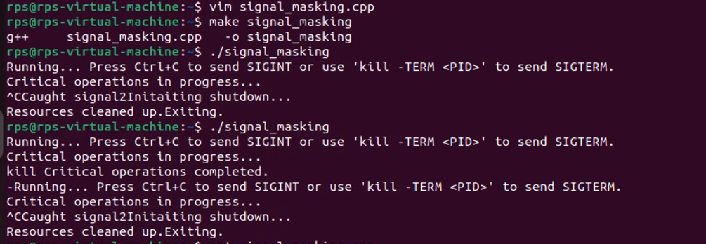

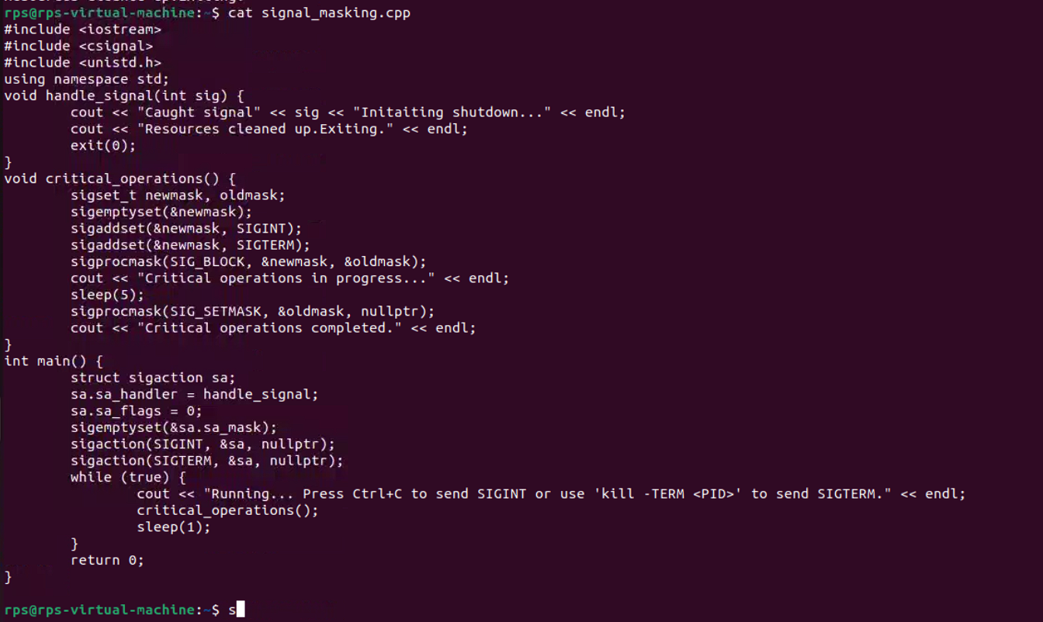

Problem Statement 3: Signal Masking and Unmasking for Error Handling

Problem: Create a C++ application that uses signal masking and unmasking to handle errors gracefully. Mask specific signals during error handling routines to prevent recursive signal delivery. Implement a mechanism to log error details and perform necessary cleanup actions before re-enabling the masked signals.

Key Challenges:

Identifying the appropriate signals to mask during error handling.

Preventing infinite recursion of signal handlers.

Ensuring proper error logging and resource cleanup.

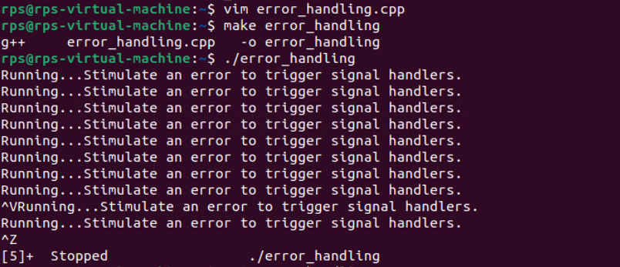

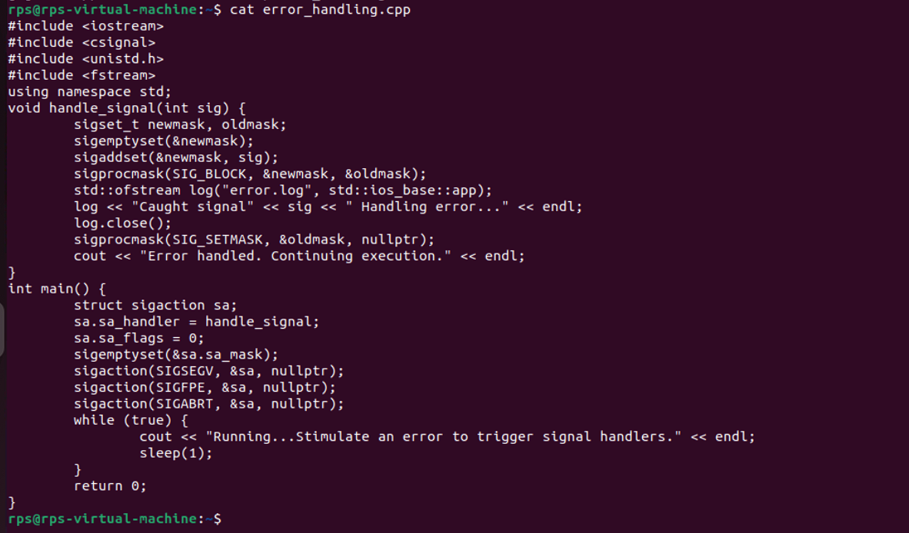

Signal file handling:

